AG-3
Cyber Resilience for an Agribusiness Back Office
AG3 Detailed Network Design

COIT20265 Networks and Information Security Project

Group PG5
CQUniversity Australia

Contents
1. Introduction 3
1.1 Three Network Design Options 3
1.1.1 Design 1 - Simplified Two-Zone Network 4
1.1.2 Design 2 - DMZ and Dual-Firewall Architecture 5
1.1.3 Design 3 - Five-VLAN Central Firewall Architecture 6
1.2 How Alternative Designs Were Made 7
2. Comparison of the Three Network Designs 8
2.1 Final Design Decision 8
3. Selected Design - Detailed Network Design 9
3.1 Target Design and Prototype Boundary 9
3.2 Assumptions 10
3.3 Network Design Diagrams and Justifications 12
3.3.1 Information Mapping and Approved Traffic Paths 14
3.4 Wi-Fi Design 15
3.5 Address Allocations 16
3.5.1 Network Services and Control Decisions 17
3.5.2 Capacity and Traffic Considerations 17
3.6 Office Subnet 18
3.7 Server Subnet 21
3.8 Security Subnet 22
3.9 Backup Subnet 24
3.10 Optional Guest Wi-Fi Subnet 25
3.11 Physical Switching and VLAN Plan 26
3.12 Recommended Hardware 26
3.13 Cost for Recommended Hardware 27
3.14 Security and Privacy Considerations 28
3.15 Design Limitations and Future Production Improvements 29
4 References 30

1. Introduction
The AG-3 project is a cyber resilience project for a small agribusiness back office. Plains Pastoral Co. relies on digital systems for accounting, supplier information, livestock and crop information, employee information and normal business communication. Since this information is vital to the company, the network must make it difficult for a compromised office device to easily access the application or monitoring, backup or administration systems. This is why the detailed network design mainly concentrates on segmenting the network, segregating communication paths and separating the different systems with different security roles.
The objective of this artefact is the design of the target head-office network of Plains Pastoral Co. Three network design options are contrasted, and the 5-core-VLAN design is selected. Selected design: Office as VLAN10, Server as VLAN20, Security as VLAN30, Backup as VLAN40, Management as VLAN99 and Guest as VLAN50 (optional extension). The design also includes IP addressing plan, Firewall communication path, Managed Switching, Wi-Fi, APP01, MON01, BKP01, planned AUTH01 and NAS01, and the target CCTV and RFID system. The hardware requirements, indicative costs, security and privacy issues and future production improvements are also included.

1.1 Three Network Design Options
Three network designs were evaluated during the AG-3 Cyber Resilience project before deciding on the detailed design. The goal was to maintain the same business process in all the options with only the placement of the security boundaries changing. All designs then include the same basic function, the normal office user, the admin workstation, the application or file server, the monitoring server, the backup server and the firewall. This separates the comparison from anything particular about a product or software platform and thus concentrates on segmentation. Network segmentation allows for systems with different security goals to be separated, which can limit propagation of compromise across the network (Australian Signals Directorate 2025).

1.1.1 Design 1 - Simplified Two-Zone Network
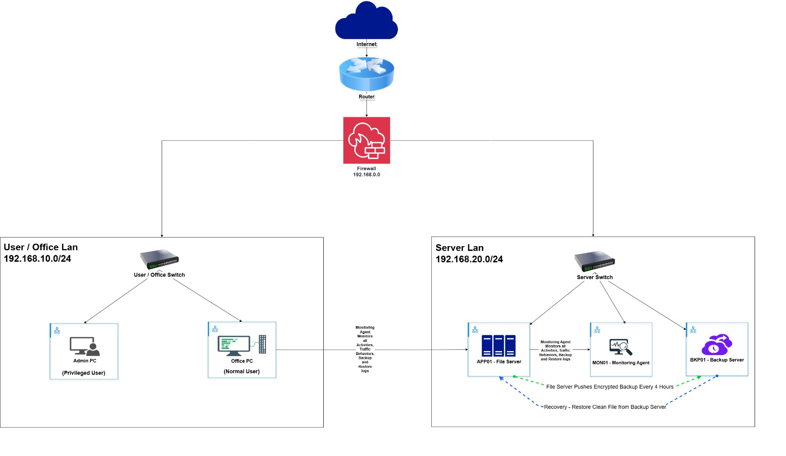
Figure 1.1. Simplified two-zone network design.
The first design has two network segments: internal and external. The normal office computer is located in the User and Office LAN while the administrator workstation is located in the User LAN. The application server, monitoring server and backup server are deployed in the Server LAN. There is one firewall between the Internet and the two internal networks, which regulates traffic at the boundaries of the internal networks.
The main reason for creating this option was simplicity. It has just two big trust zones and less firewalls decisions. The issue is that the application and monitoring/backing servers are still in the same server network. Once the application server is compromised, the attacker is in the same Layer 2 area as the monitoring and back-up systems. This design does not provide as much protection against lateral movement, as the firewall does not prevent traffic traversing the same subnet.
Zone | Example subnet | Main systems | Purpose
User and Office LAN | 192.168.10.0/24 | Office PC, Admin PC | Normal business access and administration
Server LAN | 192.168.20.0/24 | Application server, Monitoring server, Backup server | Application, monitoring and backup services

This design was not chosen because there is a demand for more separation of the application, monitoring, backup and administration functions. Even if it is an office device or the application server, the backup and monitoring systems should be protected. The two-zone design does not provide sufficient internal trust zones to achieve this. (Australian Signals Directorate 2025)

1.1.2 Design 2 - DMZ and Dual-Firewall Architecture
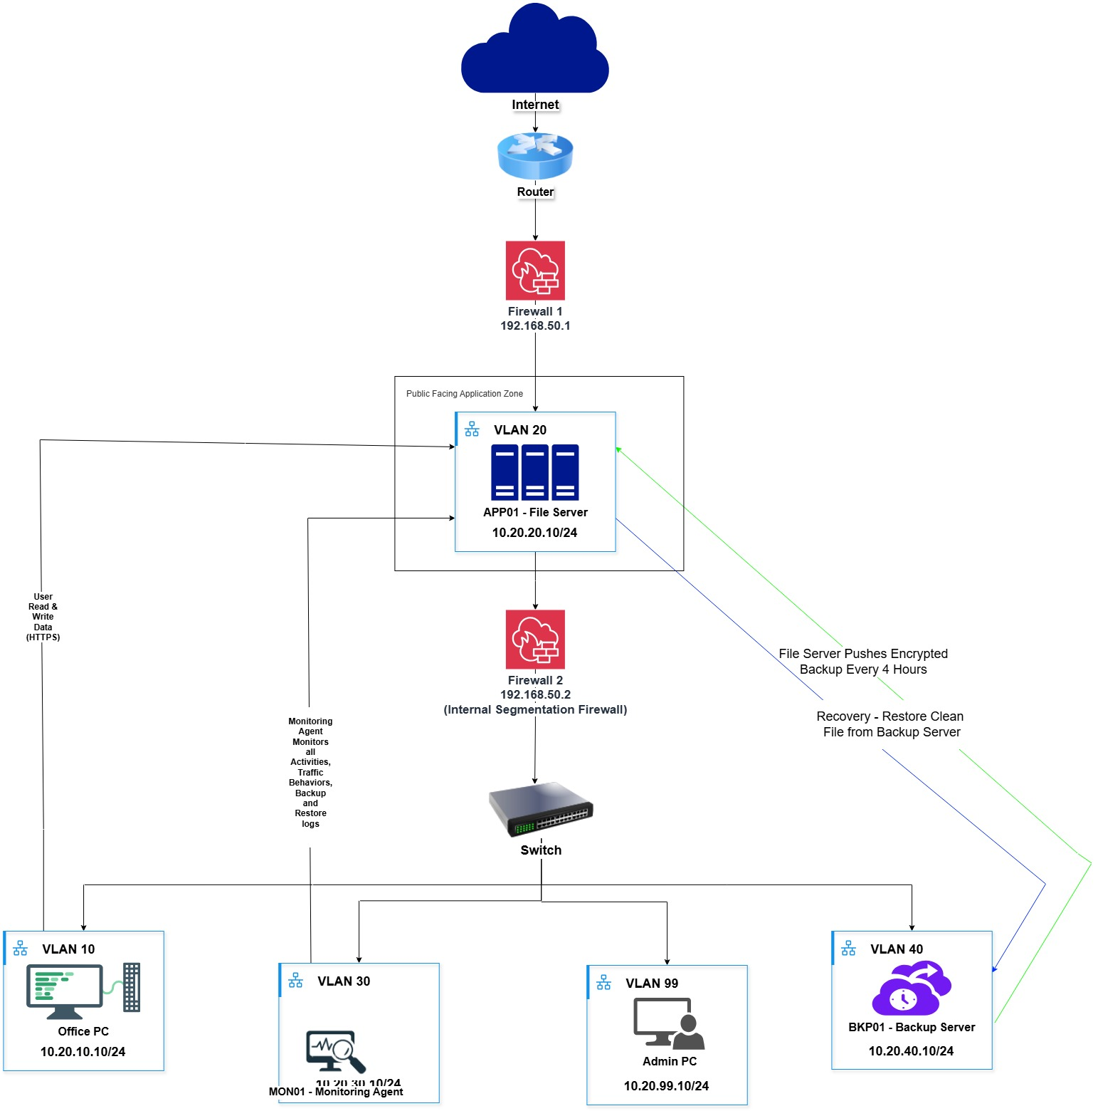
Figure 1.2. DMZ and dual-firewall architecture.

The second design has 2 layers of firewalls. A demilitarised zone (DMZ) is located inside, with application server, and Firewall 1 is located at the edge of the Internet. Firewall 2 is located between the DMZ and the internal network. A second firewall maintains the separation of the Office, Security, Backup and Management networks. The intent of this design was to determine if a separate public facing application boundary provided any useful protection to the AG-3 environment.
This type of design adds another perimeter boundary to the application server. But the primary AG-3 issue isn't about unlimited public web hosting. The project primarily aims to limit the ability of internal lateral movements and to ensure the monitoring, management and backup systems are not compromised if an office device is compromised or the application server becomes infected. There is still need for the internal Office, Security, Backup and Management networks to be separated and have their own firewall rules despite the DMZ.

Security area | Main purpose | Main systems
DMZ | Public-facing application zone | Application server
Office VLAN | Normal business use | Office client
Security VLAN | Central monitoring | Monitoring server
Backup VLAN | Recovery-data protection | Backup server
Management VLAN | Privileged administration | Administrator workstation
Firewall 1 | Internet-edge control | External traffic filtering
Firewall 2 | DMZ-to-internal control | Internal traffic filtering

This design was rejected because the second perimeter firewall is not directly addressing the AG-3 risk more than strong internal segmentation. The application server doesn't have to run as an open public Internet service and backup isolation and controlled internal traffic are still necessary in both designs. Another firewall would be an additional layer of enforcement, but the internal segmentation would still be required after the new firewall. The location of the firewall depends on the security policy and traffic needs of the environment (Scarfone & Hoffman 2009).

1.1.3 Design 3 - Five-VLAN Central Firewall Architecture
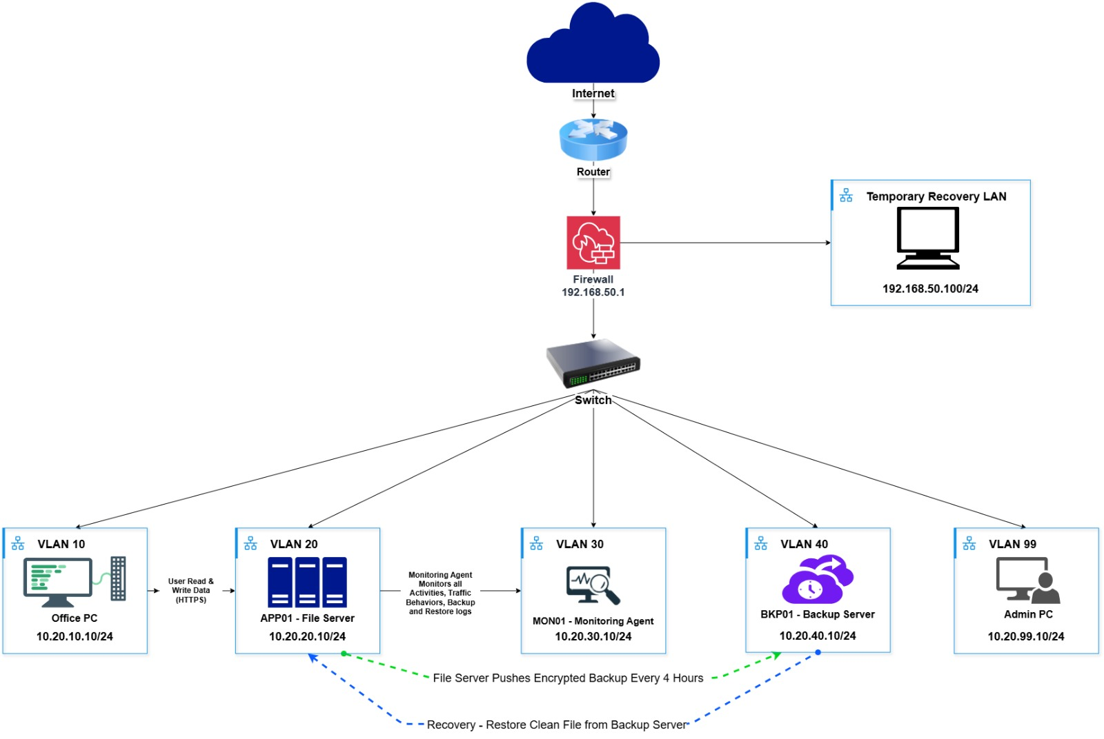
Figure 1.3. Five-VLAN central firewall architecture selected for AG-3.
The third design is based on one central firewall and five core VLANs (VLAN 10 for Office, VLAN 20 for Server, VLAN 30 for Security, VLAN 40 for Backup and VLAN 99 for Management). All of the critical functions are contained within their own trusted zone and the firewall is responsible for managing traffic that must flow between the zones. In the target design, managed VLAN-capable switching is used to enable VLAN membership to be enforced at the switching layer.
This design is intended to separate the most vital functions internally, without using another perimeter firewall. Application server is accessible to normal office users via approved business traffic, and there is no need to provide direct access to the Backup network or to the Management network. The application server starts the approved push-backup connection to the backup server, monitoring traffic is sent to the monitoring server through defined rules, and privileged administration is kept in VLAN 99. This offers one clear policy point of inter-zone communication, while maintaining the importance of the critical systems isolated.
VLAN | Name | Subnet | Main system
10 | Office | 10.20.10.0/24 | Office client
20 | Server | 10.20.20.0/24 | Application server
30 | Security | 10.20.30.0/24 | Monitoring server
40 | Backup | 10.20.40.0/24 | Backup server
99 | Management | 10.20.99.0/24 | Administrator workstation

This design was selected because it addresses the core AG3 requirements. Each of the five trust zones (Office, Server, Security and Backup and Management) are configured with their own trust zones, with one central firewall to control paths between the zones. The design also provides for separation of the backup server from normal office access without an additional public facing firewall layer.

1.2 How Alternative Designs Were Made
The three designs are all derived from the same traffic paths that were required. All Office users must have access to the application server, the application server must have an approved path to send backup data to the backup server, monitoring events must be sent to the monitoring server, and normal users of the Office should not have direct access to the backup and management system. From this base, only the number and location of the trust boundaries were changed. Design 1 has two wide zones. Design 2 is to host the application server in the DMZ with two firewalls. Design 3 involves creating 5 main internal functions, separating each function into a different VLAN behind a single central firewall. In each of the options, the same systems are used so it would be easy to see what each boundary adds to the project (Scarfone & Hoffman 2009).

2. Comparison of the Three Network Designs
The comparison of the three designs was made on the basis of the actual controls that they provide. The comparison is not overall security level scores, but rather the separation of critical functions, and how many policy boundaries are required. This makes it easier to relate the final design decision to the AG-3 requirements.
Criterion | Design 1: Two Zone | Design 2: DMZ + Dual Firewall | Design 3: Five Core VLANs
Main internal trust zones | 2 | 4 internal zones + DMZ | 5 core VLANs
Dedicated backup zone | No | Yes | Yes
Dedicated monitoring zone | No | Yes | Yes
Dedicated management zone | No | Yes | Yes
Public facing DMZ | No | Yes | No
Firewall policy points | 1 | 2 | 1 main internal policy point
Office to backup can be isolated | Only at server-zone boundary | Yes | Yes
Application server separated from backup server | No | Yes | Yes
Management separated from office users | No | Yes | Yes
Requires managed VLAN switching for target design | Not necessarily | Yes for internal zones | Yes
Fit with AG-3 main risk | Partial | Adds perimeter DMZ control not required by the core use case | Directly supports internal segmentation and backup isolation

2.1 Final Design Decision
The three options were discussed and the 5 core VLAN architecture was selected. Design 1 has the application, monitoring and recovery functions within one big server zone, which will not offer the separation required for the project. Design 2 introduces a DMZ and second firewall, but the application server does not have to be an open public Internet service, and it still needs to be separated from internal trust zones by a second firewall.
Design 3 was chosen as the most appropriate design as it has controls that are more relevant to the project. There are five separate trust zones (Office, Server, Security, Backup and Management) and a central firewall between them that controls which paths are approved. Guest Wi-Fi is optional extension (not in the 5 core VLANs). The detailed target network below is based on this design.

3. Selected Design - Detailed Network Design
This section provides detailed target network design of the selected AG-3 head office. It is a Planning model for Plains Pastoral Co and is Larger than prototype built by the team. The target design is the desired network configuration in a real office environment, and the prototype was just to prove the concept of the key security functions and the available hardware.

3.1 Target Design and Prototype Boundary
The target design includes the desired network for the head office and managed VLANs that can be supported by the managed network switching, the network zones and equipment required for the business scenario. The prototype was created to see if the concept is viable, using pfSense available to team hardware and a TP-Link LS108G unmanaged switch. The LS108G is a plug and play unmanaged switch, which cannot be used as the production switching solution (TP-Link n.d.) and is only used for the physical connection to the prototype.
Area | Target head-office design | Project prototype
Purpose | Production planning for Plains Pastoral Co. | Proof of concept and security testing
Firewall | FW01 business firewall/router with required VLAN, logging and policy functions | pfSense on available team hardware
Switching | Managed 802.1Q core/access switches; PoE where required | TP-Link LS108G unmanaged switch for physical connectivity
Core zones | Office 10, Server 20, Security 30, Backup 40, Management 99 | Same logical separation tested where practical
Guest Wi-Fi | Optional VLAN 50 extension | Not required for the core prototype
Application | APP01 plus planned AUTH01 | APP01 / Nextcloud
Monitoring | MON01 / Wazuh | MON01 / Wazuh
Backup | BKP01 and NAS01 target recovery environment | BKP01 / MinIO and Restic; push initiated by APP01
Physical security | NVR01, ACC01, CCTV and RFID in target design | Design only, not required for prototype validation

The same five zone logic is represented by the project prototype shown below. This is not a technology neutral design option like the above three but can document actual prototype products that the team tested.
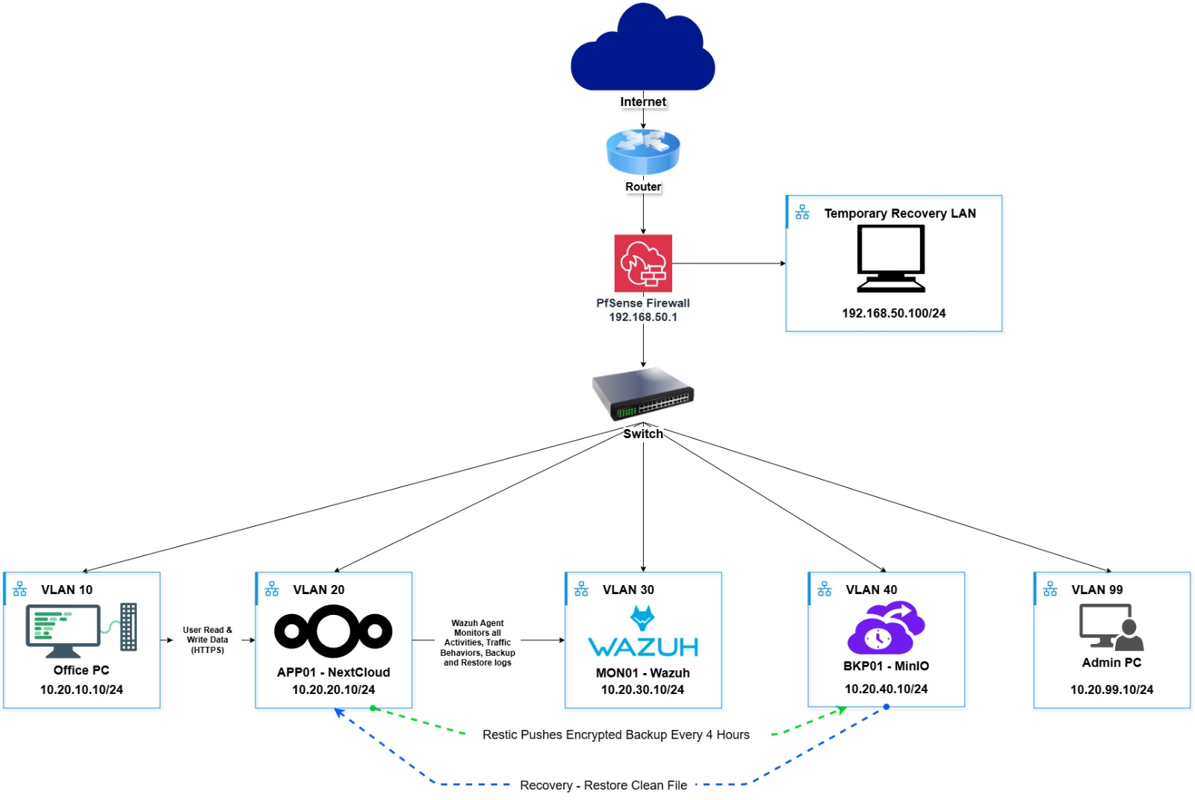
Figure 3.1. Project prototype used to validate the selected segmentation and backup flow.

3.2 Assumptions
Plains Pastoral Co. is considered to be a small agribusiness enterprise, having only a single management center in Sydney, NSW. The organisation relies on computers and digital systems for accounting, supplier management, livestock records, crop records, employee information, business customer information and for normal business communication.
These are presumed to be in one commercial building, the head office. It has employee work areas, reception, management offices, a meeting room, shared printing areas and a limited server and communications room. This design does not include a branch office. The network still has the flexibility of adding additional users, devices or a future branch later. It is assumed that the number of employees in the head office is 30. All employees have one planned computer in their office. The PCs are numbered from PC 1 to PC 30 and are assigned documented addresses via DHCP reservations. It's a design assumption and not to imply that 30 physical PCs were used in the prototype.
Department | Approximate Staff
Administration and Management | 5
Finance and Accounts | 5
Operations and Agriculture Management | 8
Sales and Customer Service | 6
Information Technology and Support | 3
Other Staff | 3
Total | 30

There are also three shared network printers, ten IP phones and two WiFi 6 APs for the target office. The wireless access of staff is included in the target design. Guest Wi-Fi is provided as an optional extra and will be switched on later if the business requires visitors to be able to use Wi-Fi.
Physical security is a part of the target design. The IP CCTV cameras are installed at 10 specific locations at the front points and reception, server room entry, office areas, storage areas, loading area/car park. The camera recordings are stored on one NVR. There are four RFID readers and one access control controller which controls the RFID permissions to access restricted doors. These are stage design devices and not claimed as prototype equipment.
Valuable network equipment is located in a controlled communications room in an office of the target. A controlled communications room is provided in the target office and houses valuable network equipment. The room contains the managed core switch, server and back-up equipment, NVR, access control equipment and UPS equipment. This room should be only accessible to authorised staff.
There are five VLANs in the core target network. The core design does not require an optional
- Office VLAN 10 - employee PCs, printers, IP phones and authorised staff devices.
- Server VLAN 20 - internal business application and planned authentication services.
- Security VLAN 30 - security monitoring and target physical-security systems.
- Backup VLAN 40 - backup server and network attached storage.
- Management VLAN 99 - privileged administration of firewall and server systems.
- Optional Guest VLAN 50 - visitor and temporary wireless devices with Internet access only.
The internal network is private IPv4. The 10.20.0.0/16 design space is inside the private 10.0.0.0/8 block defined by RFC 1918 (Rekhter et al. 1996). A /24 subnet is used for each core VLAN. This is more than is needed for the current number of devices but will leave space for growth and allow the VLAN number to be easily recognised in the third octet. Fixed addresses (important infrastructure), reserved addresses (computer in the office), temporary guest devices (DHCP – Guest network option is installed).
The assumption of the target office is that there is one business grade Internet connection available. The main firewall and router is FW01. Used to manage communication between the VLANs, between the internal network and the Internet and is the default gateway for each VLAN. This will be verified with the aid of pfSense in the prototype, but in the production firewall the selection of the firewall should be carried out based on the ultimate needs of the company.
VLAN membership is enforced at the switch port with managed switches used in the target design. If multiple VLANs are running on a shared switching infrastructure (Netgate 2026a), then 802.1Q capable switching is required. When implementing PoE capable access switches, CCTV cameras, RFID equipment, wireless access points and IP phones are preferred devices as they will reduce the number of power connections.
The target network will be designed for approximately 30 staff and provide sufficient space for more than 70 connected devices ranging from computers, phones, printers, wireless devices, servers, cameras, RFID, through to network infrastructure. The extra address space reserved is for "normal growth" not for the first day of use, setting sizes for each subnet.

3.3 Network Design Diagrams and Justifications
A single core switch (managed) and a firewall (FW01) with a target firewall role will be used for this target design. The internal network is segmented by type and sensitivity of the devices, and one gateway for each core (default) VLAN. The diagrams were designed to use ‘pfSense’ as the firewall label since the prototype used pfSense as the firewall to demonstrate the rule model. For production, FW01 can be deployed with a firewall platform with the same functionality in terms of VLAN, policy, logging and management.
Normal employee work is done on the Office subnet. It has PC 1 - PC 30, common printers and IP phones in this simplified target design. Separate zone for the security, backup and management systems of the normal office equipment from the server, eliminating unnecessary access. The regular Office network does not provide administrative access.
The planned AUTH01 service and APP01 are in the Server subnet. APP01 can be used for business uses and has been used to provide Nextcloud services. In the target design there is a future-Central identity- and authentication-service called AUTH01. Note: AUTH01 is not required in the current prototype as the application accounts and access control have already been put in place by Nextcloud.
In the target design there are four RFID readers, ten CCTV cameras, MON01, NVR01, ACC01 in the Security subnet. These devices are placed in the Security subnet because normal office users do not require access to camera configurations, surveillance recordings or RFID access permissions. The risk profile of the MON01 and the physical-security devices is also different, and a larger production environment might have cyber monitoring and CCTV/RFID on different VLANs. This residual risk isn't swept under the rug but recorded and kept with them so the small-business design stays in scope. The Backup subnet includes the following target design: BKP01 and NAS01. It is isolated from normal office users and is accessible through approved backup and administrative paths.. In AG-3, it has been adopted as a push model, where APP01 initiates the approved back-up connection and pushes the data needed to the MinIO service on BKP01. If there are normal Office clients, it is not required to be present.
It is available as an optional add-on, the Guest Wi-Fi network. When deployed, guest devices will be able to access the Internet, but not directly access Office, Security, Backup or Management networks. If VLAN 50 is not in place the heart of the AG-3 design remains intact.

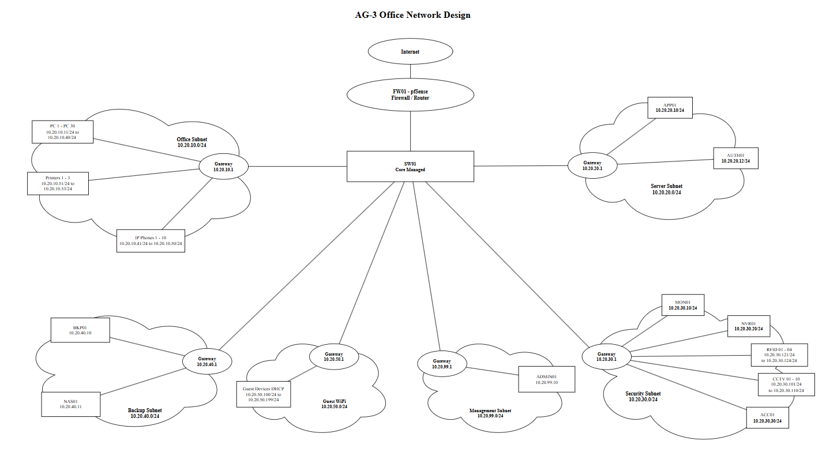
Figure 3.2. Draw.io overview of the selected AG-3 head office network design.

The above diagram (Draw.io) still displays the detailed view of addresses. The next overview displays the same target network, but in a graphical format, with the basic managed switch and additional Guest network and scheduled business devices. The information map also demonstrates business data flows between Office, Application, and Monitoring and Backup areas, and direct access restrictions.
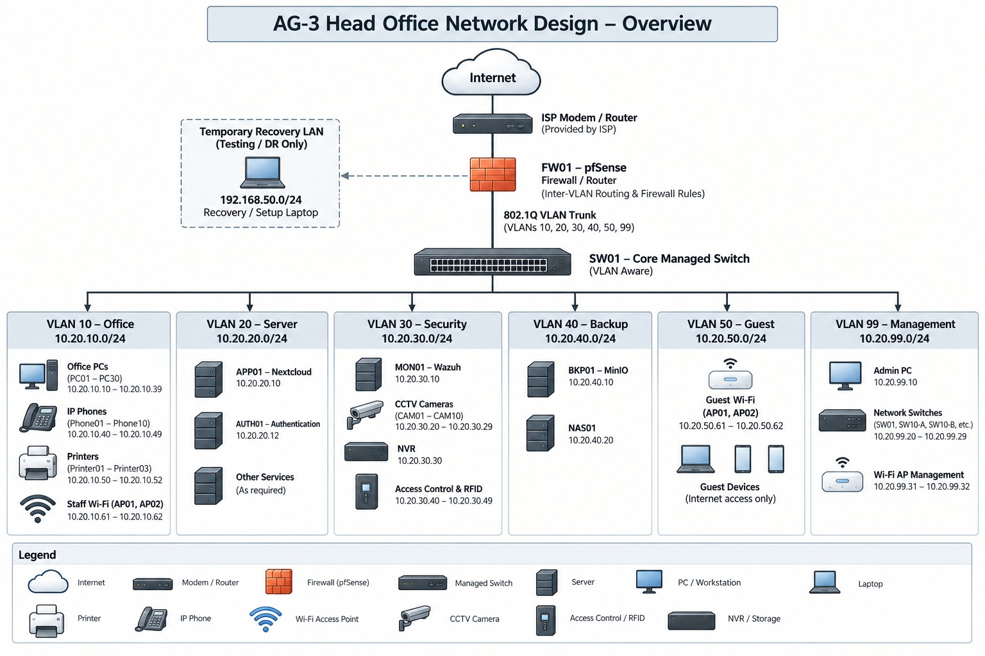
Figure 3.3. Visual overview of the target AG-3 head office network design.

3.3.1 Information Mapping and Approved Traffic Paths
The detailed network design is not just about determining what devices go into what VLANs. It is also essential to demonstrate the flow of business information from one zone to the other and the communications pathways that are needed. The main data flow between the Office, Application, Monitoring and Backup areas is shown below.
The required paths are only opened where the system needs them. Users of the Office can use the business application, APP01 can send monitoring events to MON01 and APP01 can push backup data to BKP01. Normal office users do not have direct access to the backup and monitoring systems. This helps to streamline communication between the various trust zones and separate the backup and security functions from normal user activity.
In this section, you'll see the accepted paths that are needed for normal operation, as well as the denied paths that help to safeguard the more sensitive portions of the network.

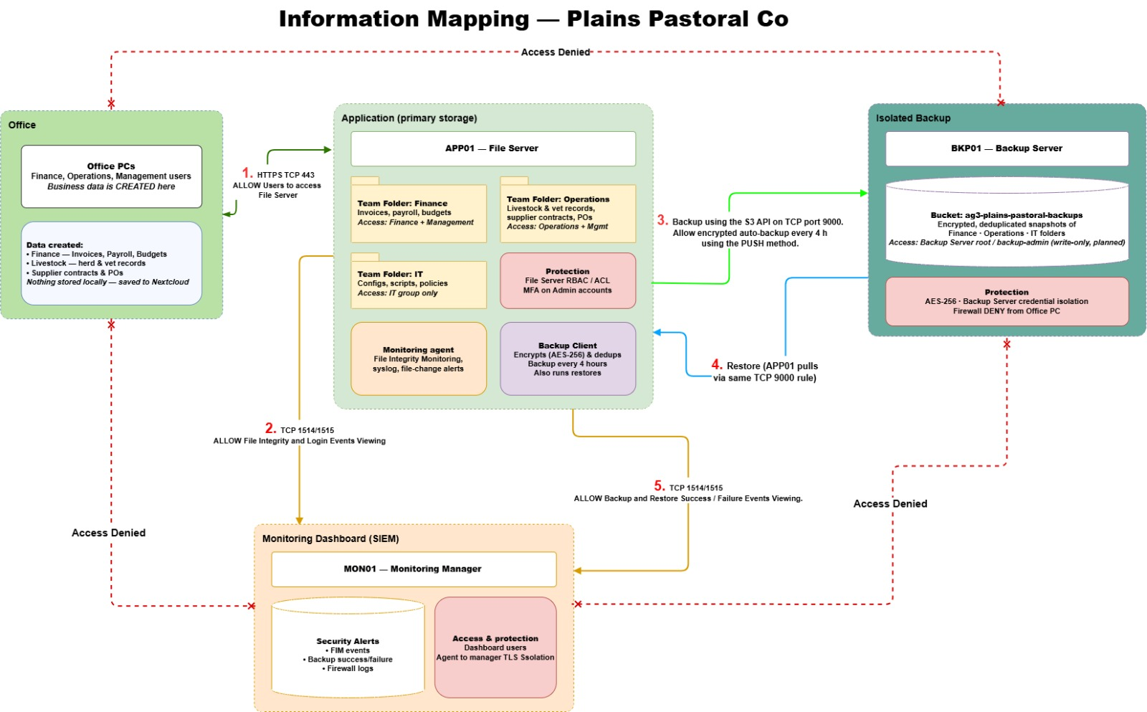
Figure 3.4. Information mapping and main allowed/denied data paths for Plains Pastoral Co.

3.4 Wi-Fi Design
The target design is based on two Wi-Fi 6 access points (2.4 GHz and 5 GHz). The staff wireless service is a standard service design with staff authorised devices mapped to Office VLAN 10. Guest VLAN 50 (an optional feature) is required to enable A separate guest SSID. A planning estimate of two access points is based on the size of the office and number of users and may be affected by walls, interference, building layout, etc. and will be determined by a wireless survey performed onsite.
Wi-Fi Setting | Value | Explanation
Wireless standard | Wi-Fi 6, 802.11ax | Supports modern devices and multiple simultaneous clients.
Frequency bands | 2.4 GHz and 5 GHz | Provides coverage and higher speed where 5 GHz is available.
Staff SSID | Plains-Staff | Places authorised staff devices into VLAN 10.
Guest SSID | Plains-Guest (optional) | Used only if optional VLAN 50 is deployed.
Channel selection | Automatic | Reduces interference between nearby access points.
Band steering | Enabled | Encourages capable devices to use 5 GHz.
Maximum clients | 30 to 40 per access point | Keeps the wireless load balanced.
Guest bandwidth | 10 Mbps per device (optional) | Example visitor limit; final value depends on Internet capacity.
Guest client isolation | Enabled when Guest Wi-Fi is used | Stops guest devices from directly communicating with each other.
Authentication | Protected staff access; separate guest policy if enabled | Keeps staff and optional guest access separate.

3.5 Address Allocations
The block of private address on 10.20.0.0/16 is used as a target head office. Does not require globally unique public addresses for internal devices (Rekhter et al. 1996) and is part of the private address space specified in RFC 1918. Each core network has a /24 subnet and typically the third octet is the VLAN number. This “/24” block is not required for the use of the present number of hosts but makes it easy to recognize the addressing and gives it easy growth space. A smaller subnet would be more efficient in using the addresses but would be of little benefit in this design for one site.
Network | VLAN | Network Address | Default Gateway
Office | 10 | 10.20.10.0/24 | 10.20.10.1
Server | 20 | 10.20.20.0/24 | 10.20.20.1
Security | 30 | 10.20.30.0/24 | 10.20.30.1
Backup | 40 | 10.20.40.0/24 | 10.20.40.1
Management | 99 | 10.20.99.0/24 | 10.20.99.1
Guest Wi-Fi (optional) | 50 | 10.20.50.0/24 | 10.20.50.1

Routing Table: FW01 (Logical Target)
Destination | Next
Internet | ISP/WAN gateway
10.20.10.0/24 Office | Directly connected VLAN 10
10.20.20.0/24 Server | Directly connected VLAN 20
10.20.30.0/24 Security | Directly connected VLAN 30
10.20.40.0/24 Backup | Directly connected VLAN 40
10.20.99.0/24 Management | Directly connected VLAN 99
10.20.50.0/24 Guest (optional) | Directly connected VLAN 50 if deployed

Main Firewall Policy
Source | Destination | Service | Action
Office VLAN 10 | APP01 in Server VLAN | HTTPS TCP 443 | Allow
Office VLAN 10 | AUTH01 in Server VLAN (target only) | Required authentication traffic only | Allow when AUTH01 is deployed
Office VLAN 10 | MON01 | Wazuh TCP 1514/1515 | Allow where endpoint agent is deployed
Office VLAN 10 | Other Security VLAN devices | Any | Deny and log
Office VLAN 10 | Backup VLAN 40 | Any | Deny and log
Office VLAN 10 | Management VLAN 99 | Any | Deny and log
Guest VLAN 50 (optional) | All core internal VLANs | Any | Deny and log
Guest VLAN 50 (optional) | Internet | DNS, HTTP and HTTPS as required | Allow
APP01 10.20.20.10 | BKP01 10.20.40.10 | MinIO API TCP 9000 | Allow - push backup
APP01 | MON01 | Wazuh TCP 1514/1515 | Allow
ADMIN-PC 10.20.99.10 | FW01 | HTTPS TCP 443 | Allow
ADMIN-PC 10.20.99.10 | APP01 / MON01 / BKP01 | Approved administration ports only | Allow
Any other inter-VLAN source | Any other internal destination | Any | Deny by default

3.5.1 Network Services and Control Decisions
DHCP is responsible for addressing and reserving the clients and an important infrastructure can reserve the fixed addresses and so the rules of the firewall and the troubleshooting are predictable. Approved DNS/NTPS services should be used to serve DNS and NTP services and not any random external DNS/NTPS service. Production firewalls can only permit these paths to the extent that the business requires their services. The project is not intended to be an IPv6 project. An IPv4-only policy is not considered to protect IPv6 traffic and should not be assumed to do so, so a production deployment must either create equivalent IPv6 firewall rules or disable IPv6 if it is not being managed.
The default denials approach is used for inter-zone traffic in the firewall policy. Only paths that are required for business, monitoring, backup and administration functions are added. This is the concept of the minimum amount of traffic allowed and denied the rest (Netgate 2026b; Netgate 2026c).

3.5.2 Capacity and Traffic Considerations
The objective is to implement the "lowest common denominator" access and switching technology as Gigabit Ethernet. CCTV streaming, large file transfers on Nextcloud and APP01 push backup to BKP01 can be some of the main traffic that may be heavy. These values will be dependent on the end camera encoding setting, file size and backup period and will need to be measured prior to investing in the production equipment. Backup jobs need to be scheduled and monitored as well so they don't impact the regular jobs in the office. If the business subsequently requires more cameras to be installed, more volume or more server traffic, higher capacity uplinks can be attached to the basic VLAN structure without any changes.

3.6 Office Subnet
Normal employee work is done on the Office subnet. Assigned by department plan – PC 1-30. In this simple design, 10 IP phones and 3 printers continue to exist in the Office VLAN, and the first 15 PCs exist in the Office VLAN via SW10-A, and PC 16 exist in the Office VLAN via SW10-B. The detailed address list is kept as there is a need to have a planing reference during the deployment process; however, the final production DHCP reservations can be modified as needed.
In order to make the identification of the office PCs easier during support and/or during firewall testing, the PCs are all set to a fixed address. These addresses will not be used by any staff wireless device or for future office devices. For a larger production network, the IP phones and network-management could be located even further apart, but to not expand the network with additional VLANs that are not required by the project scope the IP phones and network-management are kept within the Office design.
Allocated IP Addresses: Office PCs
Device | Department | Access Switch | IP Address
PC 1 | Administration and Management | SW10-A | 10.20.10.11/24
PC 2 | Administration and Management | SW10-A | 10.20.10.12/24
PC 3 | Administration and Management | SW10-A | 10.20.10.13/24
PC 4 | Administration and Management | SW10-A | 10.20.10.14/24
PC 5 | Administration and Management | SW10-A | 10.20.10.15/24
PC 6 | Finance and Accounts | SW10-A | 10.20.10.16/24
PC 7 | Finance and Accounts | SW10-A | 10.20.10.17/24
PC 8 | Finance and Accounts | SW10-A | 10.20.10.18/24
PC 9 | Finance and Accounts | SW10-A | 10.20.10.19/24
PC 10 | Finance and Accounts | SW10-A | 10.20.10.20/24
PC 11 | Operations and Agriculture | SW10-A | 10.20.10.21/24
PC 12 | Operations and Agriculture | SW10-A | 10.20.10.22/24
PC 13 | Operations and Agriculture | SW10-A | 10.20.10.23/24
PC 14 | Operations and Agriculture | SW10-A | 10.20.10.24/24
PC 15 | Operations and Agriculture | SW10-A | 10.20.10.25/24
PC 16 | Operations and Agriculture | SW10-B | 10.20.10.26/24
PC 17 | Operations and Agriculture | SW10-B | 10.20.10.27/24
PC 18 | Operations and Agriculture | SW10-B | 10.20.10.28/24
PC 19 | Sales and Customer Service | SW10-B | 10.20.10.29/24
PC 20 | Sales and Customer Service | SW10-B | 10.20.10.30/24
PC 21 | Sales and Customer Service | SW10-B | 10.20.10.31/24
PC 22 | Sales and Customer Service | SW10-B | 10.20.10.32/24
PC 23 | Sales and Customer Service | SW10-B | 10.20.10.33/24
PC 24 | Sales and Customer Service | SW10-B | 10.20.10.34/24
PC 25 | Information Technology and Support | SW10-B | 10.20.10.35/24
PC 26 | Information Technology and Support | SW10-B | 10.20.10.36/24
PC 27 | Information Technology and Support | SW10-B | 10.20.10.37/24
PC 28 | Other Staff | SW10-B | 10.20.10.38/24
PC 29 | Other Staff | SW10-B | 10.20.10.39/24
PC 30 | Other Staff | SW10-B | 10.20.10.40/24

Allocated IP Addresses: Office Shared Devices
Device | Location or Use | Access Switch | IP Address
IP Phone 1 | Reception | SW10-A | 10.20.10.41/24
IP Phone 2 | Management | SW10-A | 10.20.10.42/24
IP Phone 3 | Finance | SW10-A | 10.20.10.43/24
IP Phone 4 | Operations | SW10-A | 10.20.10.44/24
IP Phone 5 | Sales | SW10-A | 10.20.10.45/24
IP Phone 6 | IT Support | SW10-B | 10.20.10.46/24
IP Phone 7 | Meeting Room | SW10-B | 10.20.10.47/24
IP Phone 8 | Administration | SW10-B | 10.20.10.48/24
IP Phone 9 | Shared Office | SW10-B | 10.20.10.49/24
IP Phone 10 | Spare/Shared | SW10-B | 10.20.10.50/24
Printer 1 | Administration and Finance | SW10-A | 10.20.10.51/24
Printer 2 | Operations and Sales | SW10-B | 10.20.10.52/24
Printer 3 | General shared printing | SW10-B | 10.20.10.53/24
Access Point 1 | Staff and guest wireless coverage | SW10-A | 10.20.10.61/24
Access Point 2 | Staff and guest wireless coverage | SW10-B | 10.20.10.62/24

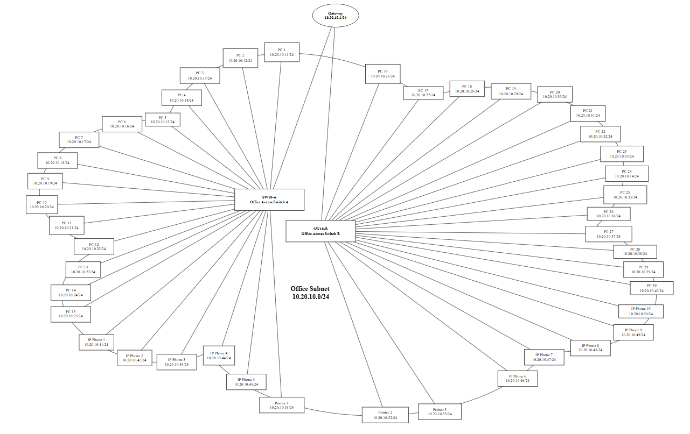
Figure 3.5. Office VLAN 10 detailed device and address allocation.

3.7 Server Subnet
Services are provided by the business systems that are hosted in the Server subnet. The direct impact of the normal office equipment, as well as access to the services via a firewall control, is carried out through a separate server network.
Device | Purpose | IP Address
Gateway | FW01 VLAN 20 gateway/interface | 10.20.20.1/24
APP01 | Business application and Nextcloud | 10.20.20.10/24
AUTH01 | Authentication service | 10.20.20.12/24

Only the appropriate app traffic is expected to access APP01 from the office. AUTH01 is the planned service for central identity and authentication but it is not implemented as part of the current prototype, . If AUTH01 is to be implemented, then only the authentication protocol(s) which are required are to be opened through the firewall. This should be known as an Identity Service, not a password repository. Access to the Server subnet is not allowed for guests.
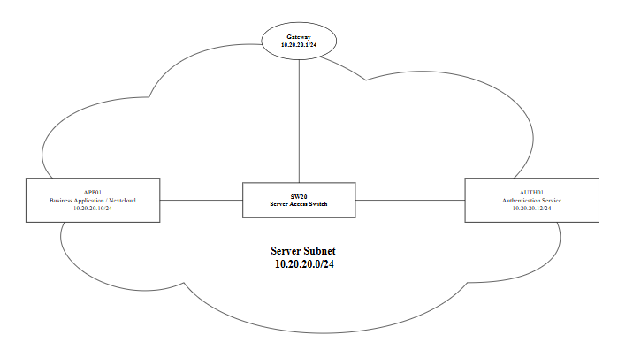
Figure 3.6. Server VLAN 20 detailed address allocation

3.8 Security Subnet
The Security subnet includes cyber security monitoring devices as well as physical-security devices targeted. General access to the Office network is not allowed as is normal, and normal office users do not have to alter the camera setting, delete any recordings, etc., or administer MON01. The firewall allows the required Wazuh agent communication path to MON01 for endpoints where the agent is deployed.
Like the RFID readers, individual addresses are given to the CCTV cameras so that they can correlate which camera and/or door was involved in a particular event. NVR01 is the CCTV recording system, ACC01 is the RFID access system and MON01 is the cyber security monitoring system. For the small target design, it is a simplification to place MON01 and physical-security devices on the same VLAN. If the business grows or if the physical-security devices were deemed to be at lesser risk, MON01 should be placed on a separate monitoring VLAN or a compromised one or controller cannot communicate with MON01 at Layer 2.
Device | Purpose or Location | IP Address
MON01 | Security monitoring server | 10.20.30.10/24
NVR01 | Network video recorder | 10.20.30.20/24
ACC01 | Access control controller | 10.20.30.30/24
CCTV Camera 1 | Main entrance | 10.20.30.101/24
CCTV Camera 2 | Reception | 10.20.30.102/24
CCTV Camera 3 | Rear entrance | 10.20.30.103/24
CCTV Camera 4 | Server room entrance | 10.20.30.104/24
CCTV Camera 5 | Main office area | 10.20.30.105/24
CCTV Camera 6 | Meeting room corridor | 10.20.30.106/24
CCTV Camera 7 | Storage area | 10.20.30.107/24
CCTV Camera 8 | Loading and delivery area | 10.20.30.108/24
CCTV Camera 9 | Car park | 10.20.30.109/24
CCTV Camera 10 | Rear yard or emergency exit | 10.20.30.110/24
RFID Reader 1 | Main staff entrance | 10.20.30.121/24
RFID Reader 2 | Server room | 10.20.30.122/24
RFID Reader 3 | Records or storage room | 10.20.30.123/24
RFID Reader 4 | Restricted management area | 10.20.30.124/24

RFID Reader 1, RFID Reader 2, RFID Reader 3 and RFID Reader 4 are connected to the four controlled doors. This is a simplified design where there is no need for separate IP addresses for the locks and the locks are controlled by ACC01. Records of access and CCTV footage may contain personal information about staff and visitors and should be kept and only looked at for business purposes and not by the day to day users in the offices.
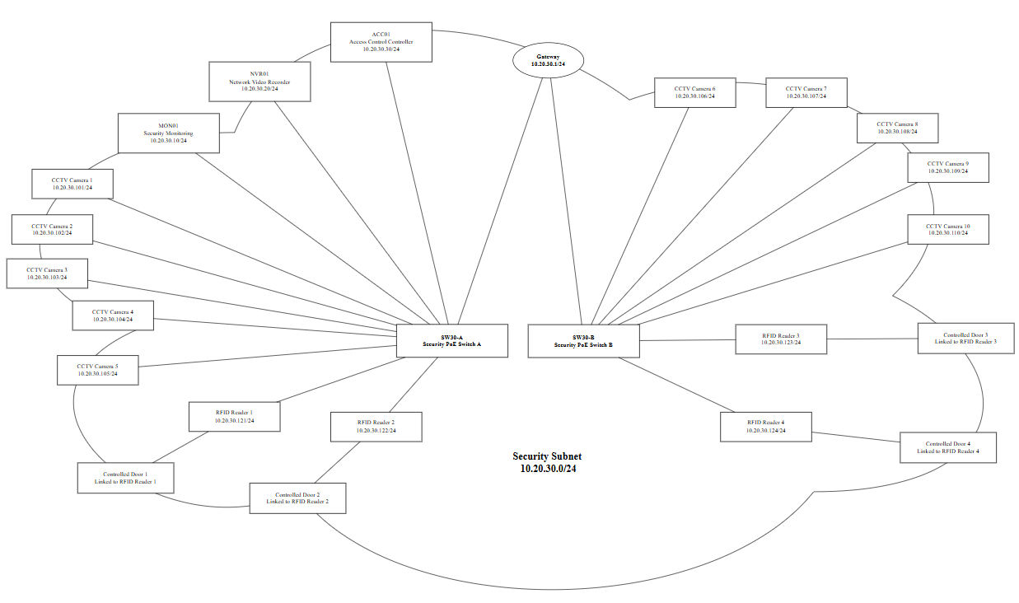
Figure 3.7. Security VLAN 30 with individual CCTV, RFID and monitoring devices.

3.9 Backup Subnet
The Backup subnet is used for systems that are meant to safeguard the vital business data. It is not connected to the Office network like other data center services in the Office network are connected. The target design will have additional storage (NAS01) used as a backup service (BKP01). To verify the backup process, a prototype is used, which involves MinIO and Restic on BKP01.
Device | Purpose | IP Address
Gateway | FW01 VLAN 40 gateway/interface | 10.20.40.1/24
BKP01 | Main backup server and repository | 10.20.40.10/24
NAS01 | Secondary network attached storage | 10.20.40.11/24

AG-3 uses a push-based backup model. APP01 initiate the backup connection and send the required backup data to BKP01 API through the authorized firewall path. The Backup VLAN is not accessible to Office clients. The backup identity used by APP01 should have only the permissions required to perform the backup job. Therefore, the entire back-up and recovery process is managed via APP01 as opposed to the normal office user.
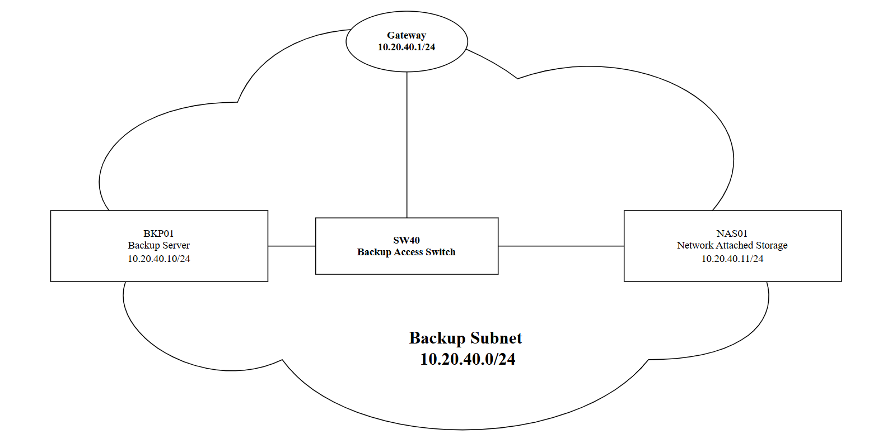

Figure 3.8. Backup VLAN 40 detailed address allocation

.

3.10 Optional Guest Wi-Fi Subnet
Guest Wi-Fi subnet is an optional extension for guest, contractors and temporary devices. Not necessary for the five core VLAN design or for the prototype. Guest devices will be allocated an address from a DHCP address pool (10.20.50.100 - 10.20.50.199) and will not be issued with a fixed business address.
Device or Range | Address | Purpose
Gateway | 10.20.50.1/24 | Optional default gateway for guest devices.
DHCP Pool | 10.20.50.100 to 10.20.50.199 | Temporary guest addresses if VLAN 50 is deployed.
Guest AP 1 | 10.20.10.61/24 | AP management remains in Office VLAN; optional guest client traffic uses VLAN 50.
Guest AP 2 | 10.20.10.62/24 | AP management remains in Office VLAN; optional guest client traffic uses VLAN 50.

If the Guest network is enabled, guests will only be able to access the Internet. The VLAN 50 traffic cannot go to the Office, Server, Security, Backup and Management VLANs. This prevents devices which are used by visitors from getting inside the business trust areas.
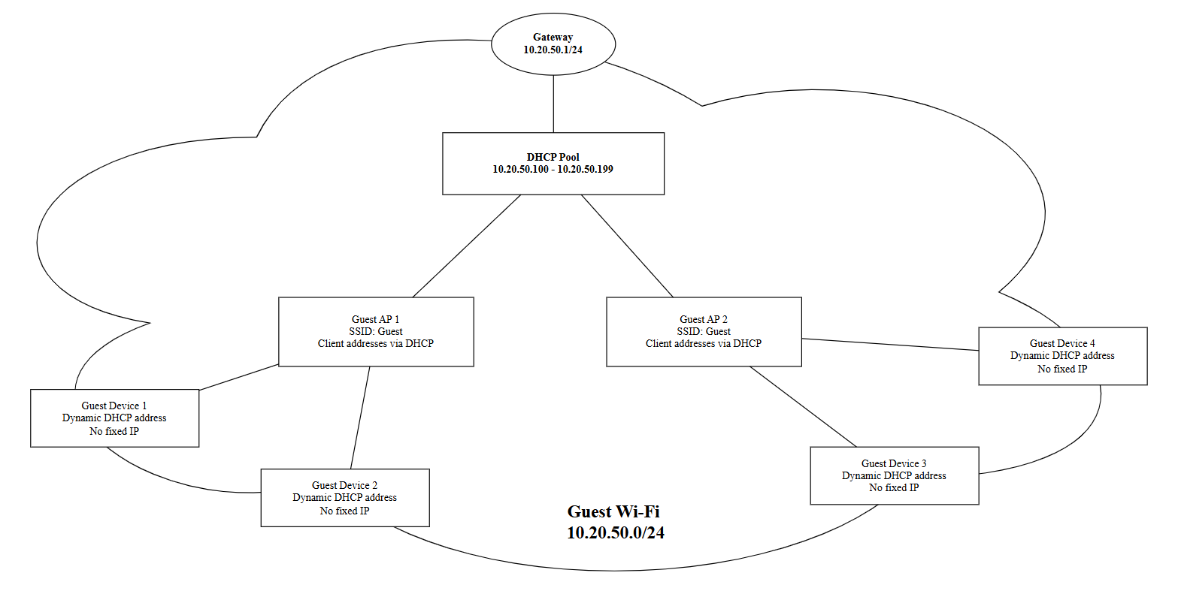

Figure 3.9. Optional Guest VLAN 50 with DHCP based client addressing.

3.11 Physical Switching and VLAN Plan
The desire head-office design is the core switch SW01 and back to the head-office via links that are VLAN aware, from the subnet access switches. It is a production planning model, not prototype hardware. Managed switching is being utilized as membership to VLAN's must be enforced at the switch ports and transported between the access layer, core and firewall (Netgate 2026a). During testing, the prototype of the project only uses the TP-Link LS108G unmanaged switch to connect physical devices; the behavior of the VLAN is determined by pfSense and the connected hosts.
Switch | Network | Main Connected Devices
SW01 | Core | Carries core VLANs 10, 20, 30, 40 and 99. Optional VLAN 50 can be added if Guest Wi-Fi is deployed.
SW10-A | Office | PC 1 to PC 15, IP Phone 1 to 5 and Printer 1.
SW10-B | Office | PC 16 to PC 30, IP Phone 6 to 10 and Printers 2 to 3.
SW20 | Server | APP01 and AUTH01.
SW30-A | Security | MON01, NVR01, ACC01, CCTV 1 to 5 and RFID Readers 1 to 2.
SW30-B | Security | CCTV 6 to 10 and RFID Readers 3 to 4.
SW40 | Backup | BKP01 and NAS01.

3.12 Recommended Hardware
The following is the minimum specification recommended for the target head-office design. Such is the planning requirements and not the prototype equipment. Security features, cost, warranty, support and availability should be taken into account to choose the final model. The production firewall needs to be able to support the required VLANs, stateful policy, logging and secure administration, and the production switches need to be able to support 802.1Q VLANs. Phones, access points, cameras or access-control equipment are the only devices that need PoE.
Device | Quantity | Recommended Minimum Specification
Firewall | 1 | 1 Gbps or higher firewall throughput, VLAN support, VPN, logging and multiple Gigabit interfaces.
Core managed switch | 1 | Managed Gigabit switch with 802.1Q VLAN support, trunking and sufficient uplink capacity.
Office managed PoE+ switch | 2 | 24 port or higher managed Gigabit switch with PoE+ for phones and access points.
Server managed switch | 1 | 8 port or higher managed Gigabit switch with VLAN support.
Security managed PoE+ switch | 2 | 16 or 24 port managed PoE+ switch suitable for CCTV and RFID devices.
Backup managed switch | 1 | 8 port or higher managed Gigabit switch.
Employee PCs | 30 | Intel Core i5 class CPU, 16 GB RAM, 512 GB SSD and Gigabit Ethernet or WiFi 6.
Network printers | 3 | Business network printer with Ethernet or secure wireless support.
IP phones | 10 | PoE capable SIP phone with Gigabit pass through where required.
Wi-Fi 6 access points | 2 | Dual band 2.4 GHz and 5 GHz, VLAN SSID support and central management.
Application server | 1 | 64 bit server, minimum 16 GB RAM, SSD storage and redundant backup.
Authentication server | 1 | 64 bit server, minimum 8 GB RAM and protected system storage.
Backup server | 1 | Minimum 16 GB RAM with protected local backup storage.
NAS | 1 | RAID capable storage with at least 8 TB usable capacity for business backup growth.
CCTV cameras | 10 | PoE IP camera, minimum 1080p, IR night vision and ONVIF support.
NVR | 1 | 16 channel NVR with approximately 8 TB or higher usable storage.
RFID readers | 4 | Network capable or controller connected RFID access reader.
Access controller | 1 | Supports at least four controlled doors and central access logging.
Controlled door locks | 4 | Electronic locks compatible with the selected access controller.
UPS | 2 | Network manageable UPS units for firewall, switches, servers, NVR and backup equipment.
Rack and cabling | 1 set | Lockable communications rack, patch panels and Cat6 structured cabling.

3.13 Cost for Recommended Hardware
Below is an indicative planning table of costs of products that have already been collected by the team. This is not a last order quotation. Prices to be reconfirmed before purchase and the final list shall show confirmation of the following: GST, Warranty, Storage media, Rack/cabling and subscription. The firewall product listed here is a production candidate and not to be confused with the pfSense prototype.
Product / Intended Role | Indicative Unit Cost x Quantity (AUD) | Source
TP-Link Omada ER7406 - candidate production firewall/gateway | 229 x 1 | link
Ubiquiti UniFi 16-Port Managed Gigabit Switch | 547 X 1 | Link
Ubiquiti | USW-Pro-HD-24-PoE | 2002 x 2 | Link
TP-Link TL-SG2008 8 Port Gigabit Desktop Smart Switch | 114 x 1 | Link
Hikvision 24 Port Managed PoE Switch | 621 x 2 | Link
TP-LINK TL-SX3008F Network Switch Managed | 364 x 1 | Link
HP 27 inch All-in-One Desktop PC 27-cr0027a | 1059 x 30 | Link
Brother MFC-L5915DW Mono Laser Printer | 688 x 3 | Link
Yealink SIP-T33G - 4 | 129 x10 | Link
TP-Link EAP613 AX1800 Ceiling Mount WiFi 6 Access Point | 159 x 2 | Link
Fujitsu Primergy TX1330 M5 - candidate APP01/AUTH01 host | 3977 x 1 | Link
Dell PowerEdge R260 - candidate MON01 host | 6310 x 1 | Link
QNAP TS-1673AU-RP-16G - NAS01 storage | 6530 x 1 | Link
IVSEC 4MP 2-PACK Turret Dome 95° | 398 x 5 packs (10 cameras) | Link
216MH-C16P HiLook 16CH NVR | 323 x 1 | Link
Ubiquiti UniFi Access Reader G2 | 238 x 4 | Link
Hikvision DS-K2704X | 600 x 1 | Link
Ubiquiti UniFi Electric Lock | 135 x 4 | Link
APC Smart-UPS X 3000VA/2700W | 5170 x 2 | Link

Camera Packs Qty Corrected: 12, Door Locks Qty Corrected: 34, Indicative priced Sub Total (based on current listed prices): AUD $73,504. This subtotal does not include the cost of a dedicated BKP01 production server, rack/cabling, storage disks (if applicable), subscriptions or delivery or installation charges.

3.14 Security and Privacy Considerations
The proposed network will seek to ensure that critical business data is protected, and to reduce the possibility of unauthorized network traffic between systems. Plains Pastoral Co. might keep records of financial transactions, suppliers, customers, employees, physical-security records. This is because not all internal devices can be relied on in the design. The core network is divided into Office, Server, Security, Backup and Management zones with Guest Wi-Fi as an optional extension. ASD considers network segmentation as one of the ways to limit the spread of malicious activity within a network (Australian Signals Directorate 2025).
FW01 is responsible for communicating between zones and only those paths that are needed are opened. Normal office users need only have access to APP01; direct access to BKP01 and/or the management network is not required. Administrative access is kept in VLAN 99. It's an idea that accompanies having a device in the organisation and not having access, due to the role and the resource. (Rose et al. 2020)
Important identity and business info is present in APP01 and planned AUTH01 service. Individual accounts to be used and Multi factor authentication to be used (where applicable). The prototype provides application accounts and TOTP function and AUTH01 is a component to be designed. TOTP is a second factor authentication (2FA) for Nextcloud (Nextcloud GmbH 2026).
Target CCTV/RFID systems are installed in the Security network. Access control events and monitoring logs and CCTV footage may show information about employees and visitors, which should only be seen and accessed by authorised individuals. Don't store data elements that are not being used. Should be retained for a business or security reason - not just to be retained. If there is a greater production risk, cyber monitoring and physical-security devices should be on different VLANs.
Normally, no office users are on the Backup network and APP01 pushes data to BKP01 in the AG-3 network. Only the required App01-BKP01 backup path is permitted on the firewall and that Office-to-Backup access is denied. Back up credentials should not be the same as the user's and should be granted the minimum privileges required to perform the backup job. This will make it useful even if a regular user's account is compromised. If using optional Guest Wi-Fi network, Internet access only and it is not a part of the business trust zones. Guest devices are not allowed to connect to the Office, Server, Security, Backup and Management. This can be skipped if the business doesn't want to provide network access to visitors.
Separation, least privilege, controlled administration, monitoring and protected backup are all related controls. The prototype demonstrates the main security functions of pfSense, APP01, MON01 and BKP01 using the available equipment. Managed switching and other production infrastructure remain future requirements.

3.15 Design Limitations and Future Production Improvements
The design is purposely kept on a small-business level, which means there are some restrictions. The actual products were not used for testing in the prototype pfSense system and TP-Link LS108G unmanaged switch are used for testing the main controls. In the target network, there are still one single point of failure for the central firewall and another one for the core switch. If the business might eventually require even more availability, a redundant pair of firewalls, redundant switching and another Internet service may be desirable.
The target Security VLAN also maintains all of the MON01 equipment along with the CCTV and RFID equipment to remain within the scope of the design. This must be checked prior to production as embedded physical-security devices may have a different risk level than the monitoring server. Guest Wi-Fi remains optional, the two-AP design requires validation through an onsite wireless survey, and IPv6 is outside the current design scope. If remote administration is needed in the future, then it should be done via an acceptable VPN and through the use of robust authentication and only access to the management zone.

4 References
Australian Signals Directorate 2025, Information Security Manual, Australian Cyber Security Centre, viewed 20 September 2026, https://www.cyber.gov.au/sites/default/files/2025
Netgate 2026a, Virtual LANs (VLANs), pfSense Documentation, viewed 23 September 2026, https://docs.netgate.com/pfsense/en/latest/vlan/index.html.
Netgate 2026b, Rule Methodology, pfSense Documentation, viewed 23 September 2026, https://docs.netgate.com/pfsense/en/latest/firewall/rule-methodology.html.
Netgate 2026c, Firewall Rule Best Practices, pfSense Documentation, viewed 23 September 2026, https://docs.netgate.com/pfsense/en/latest/firewall/best-practices.html.
Nextcloud GmbH 2026, Two-factor authentication, Nextcloud Server Administration Manual, viewed 24 September 2026, https://docs.nextcloud.com/server/stable/admin_manual/configuration_user/two_factor-auth.html.
Rekhter, Y, Moskowitz, B, Karrenberg, D, de Groot, GJ & Lear, E 1996, Address Allocation for Private Internets, RFC 1918, RFC Editor, viewed 22 September 2026, https://www.rfc-editor.org/info/rfc1918/.
Rose, S, Borchert, O, Mitchell, S & Connelly, S 2020, Zero Trust Architecture, NIST Special Publication 800-207, National Institute of Standards and Technology, viewed 22 September 2026, https://doi.org/10.6028/NIST.SP.800-207.
Scarfone, K & Hoffman, P 2009, Guidelines on Firewalls and Firewall Policy, NIST Special Publication 800-41 Revision 1, National Institute of Standards and Technology, viewed 23 September 2026, https://doi.org/10.6028/NIST.SP.800-41r1.
TP-Link n.d., LS108G 8-Port 10/100/1000Mbps Desktop Switch, TP-Link Australia, viewed 24 September 2026, https://www.tp-link.com/au/business-networking/soho-switch-unmanaged/ls108g/.
Wazuh 2026, Architecture - Getting started with Wazuh, Wazuh Documentation, viewed 24 September 2026, https://documentation.wazuh.com/current/getting-started/architecture.html.

